ANSWERS(ASSIGNMENT 3)

1)MAN COMMAND

- Displays the complete manual page of a command with detailed explanation.
- Detailed documentation, syntax, options and examples.
- Used for learning a command in depth.
“man ls” command
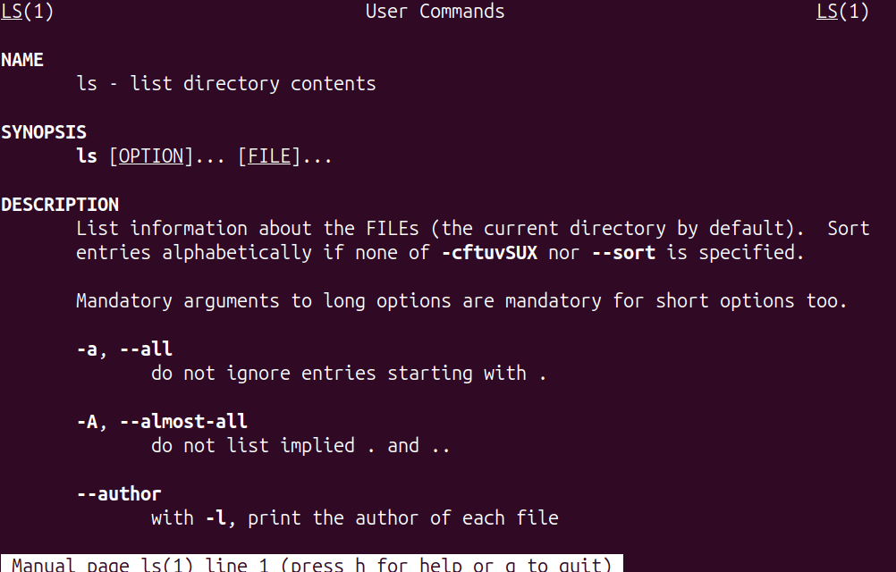

WHATIS COMMAND

- Gives a one-line brief description of a command.
- Short summary line from the manual page database.
- Used for quickly identifying what a command does.
“whatis ls” command

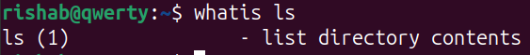

2)The command to save the output of tee command to a file named “output.txt” is
“ls -l |tee output.txt”

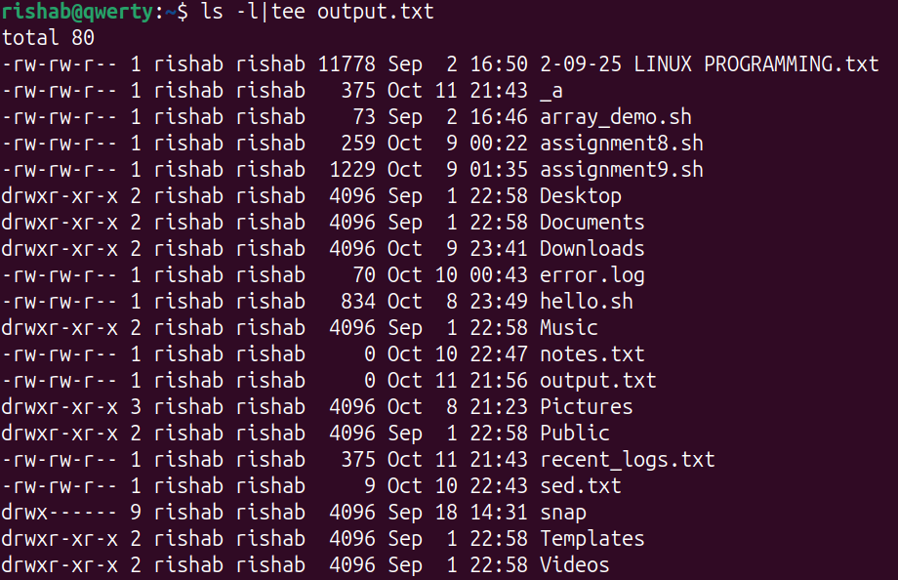
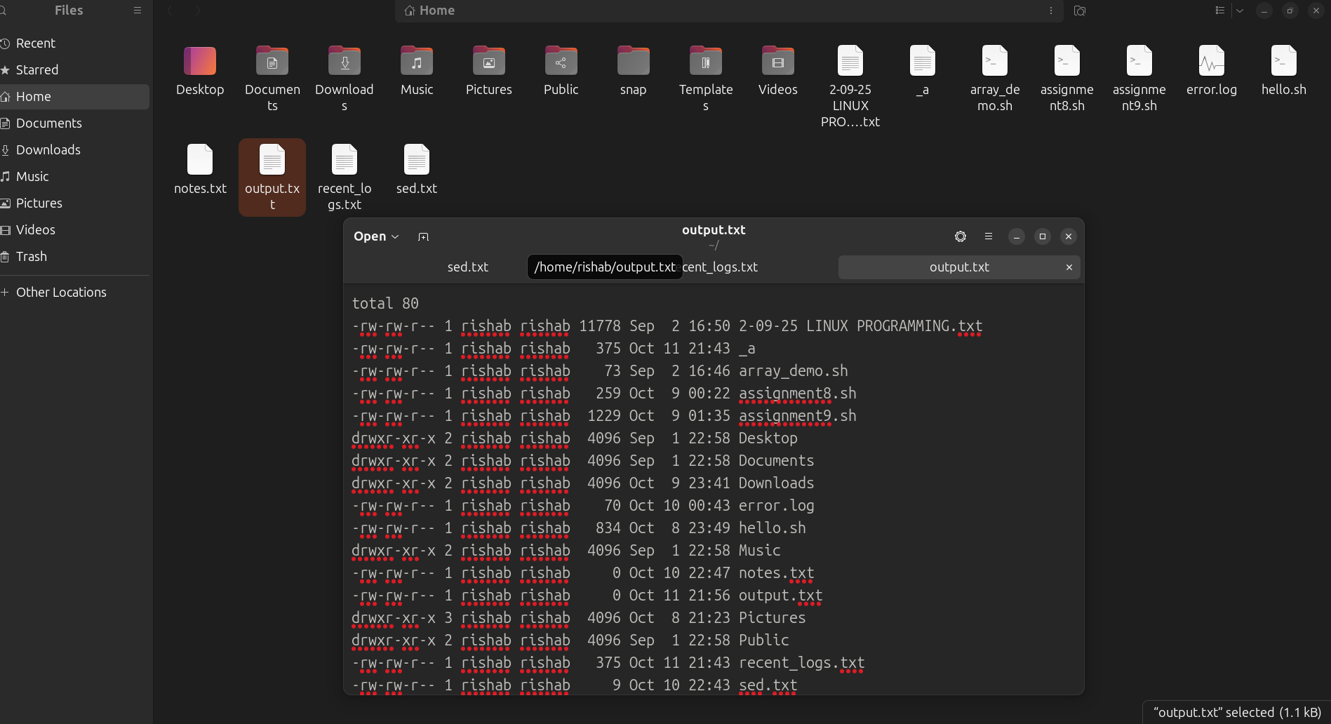

3) “ping google.com|tee -a ping.txt”
The ping command sends ping to “google.com”. The tee -a appends the output to a log file while showing it live on the screen. Used for system or network logging where you want to view and record output simultaneously.

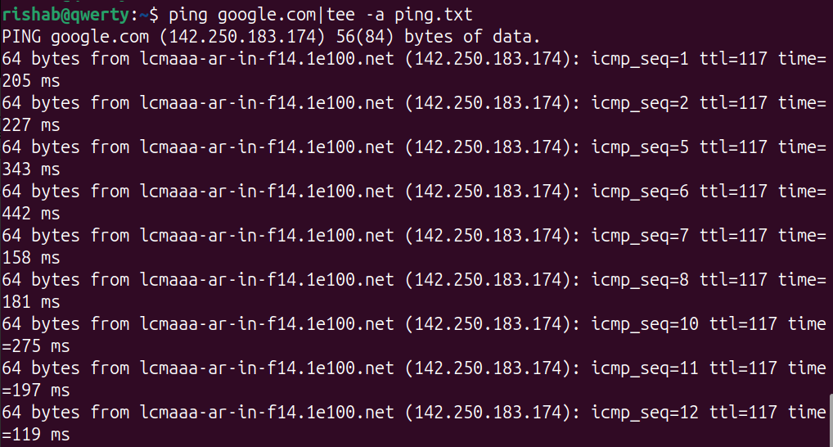
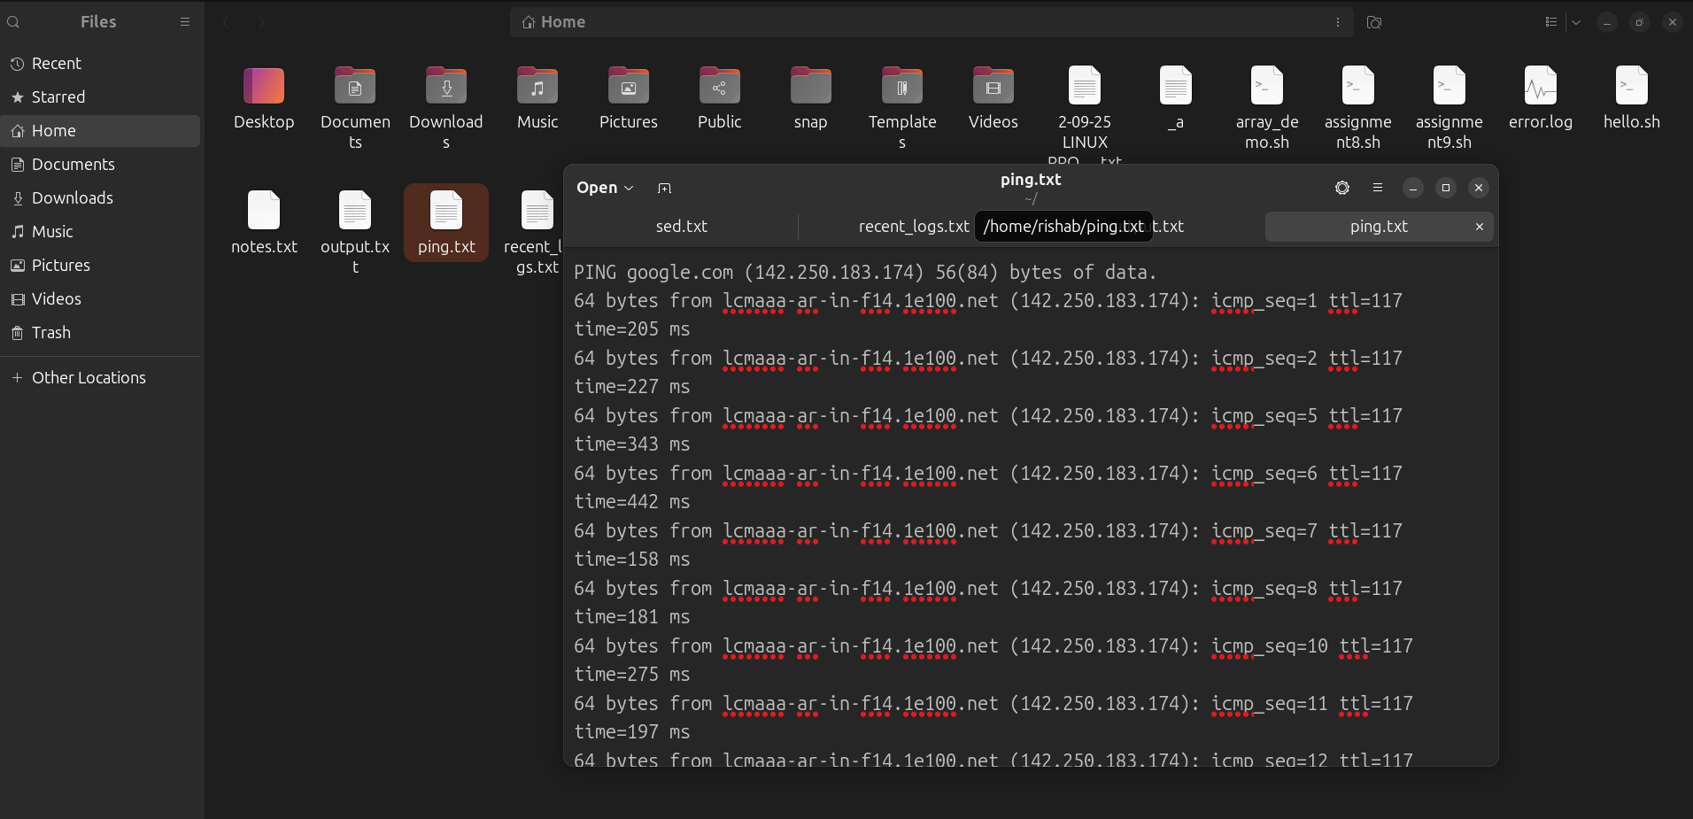

4)Steps to install:
- Download Ubuntu ISO image from the official ubuntu website.
- Open VirtualBox
- Click new to create a virtual machine.
- Select the ISO image.
- Assign at least 4gb ram.
- Assign at least 25gb of hard disk space.
- Start VM.
- Follow the installation steps.
- Create a username/password.
- Reboot the virtual machine.

5)Common causes of kernel panics include:

- Hardware issues, such as faulty RAM, failing hard drives, or incompatible peripherals.
- Software problems, including buggy or incompatible device drivers, corrupted system files, or flawed kernel updates.
- Misconfigurations in the boot process, such as a missing or corrupted initramfs file, which is essential for loading the root filesystem during boot.
- Errors during kernel compilation, installation, or upgrades, especially when new kernels are not properly configured or lack compatible drivers .
- Failure to locate the root file system or issues with the init process, which is the first process started by the kernel and must remain running.

To resolve a kernel panic, troubleshooting steps include:

- Rebooting the system and attempting to boot using a previously working kernel version via the GRUB menu.
- Using a serial console or rescue mode to access the system and repair the issue.
- Regenerating or reinstalling the initramfs file using tools like dracut.
- Repairing filesystems with fsck.
- Checking hardware integrity using tools like memtest for RAM and smartctl for disk health.
- Updating or downgrading the kernel and drivers to ensure compatibility.
- Reviewing system logs and crash reports to identify the specific error.

6)The command to display host name is “hostname”.

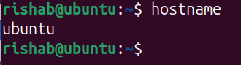

The command to change hostname using sysctl is
“sudo hostnamectl set-hostname linux”
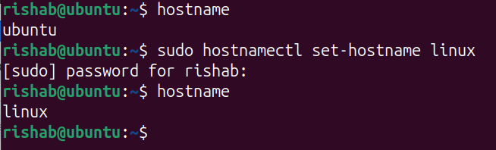

7)The command to display the calender of august 1984 is “cal 8 1984”
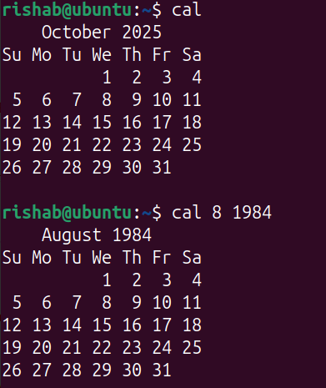

8)The command to display the uptime and the users who are logged in is “w”
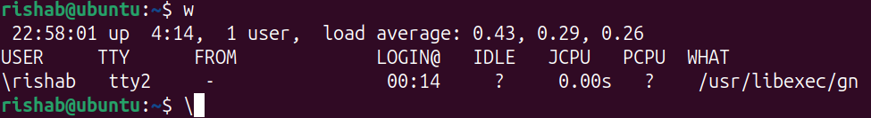
Another command to display uptime and users who are logged in is
“uptime&&who”
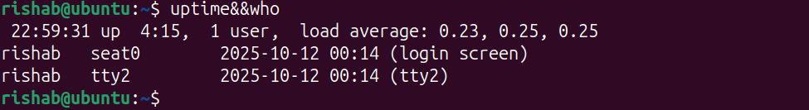

9)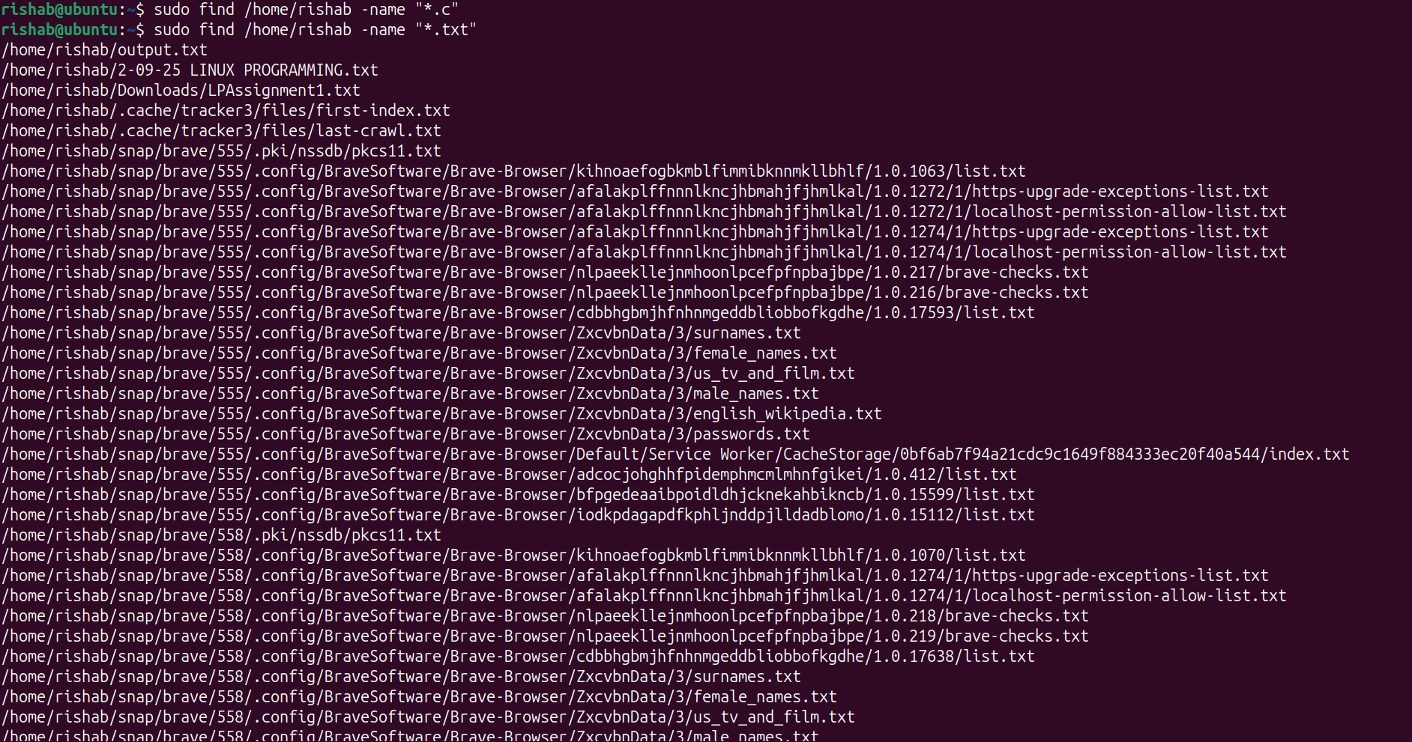

10)The command is
“chmod 600 filename”

